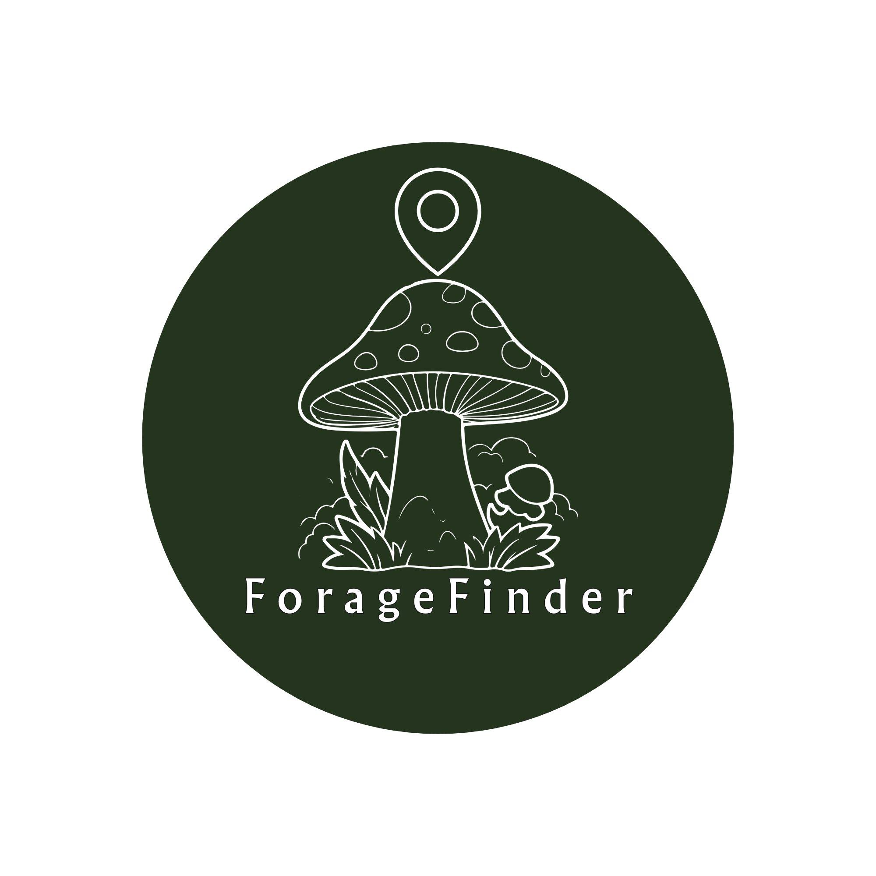
ForageFinder
User Instruction Manual
Version 1.0
Spring 2025
foragefinder.app

Table of Contents
1. Introduction | 3
What makes ForageFinder different | 3
2. Safety Warnings | 4
Critical warnings before use | 4
The golden rules of safe foraging | 4
3. Getting Started | 5
System requirements | 5
Step-by-step setup | 5
4. Using ForageFinder | 6
How to identify a plant or mushroom | 6
How to log a find to the map | 6
How to use the community map | 6
5. Seasonal Calendar | 7
6. Frequently Asked Questions | 8
7. Responsible Foraging Guidelines | 9
8. Contacting ForageFinder | 10

1. Introduction
ForageFinder is a free mobile app that helps people find, identify, and safely harvest wild edible plants, mushrooms, berries, and nuts near them. The basic concept works a lot like geocaching. Users go out into the field, find something interesting, take a photo, and log the location on a shared community map. Other users can see those finds on the map, comment on them, and confirm or deny the identification.
What makes the app different from other plant ID apps is that it uses two identification systems at the same time rather than just one. It also includes a safety layer that automatically checks every result against a database of toxic lookalikes, which is especially important for mushrooms where misidentification can be dangerous. The app also has a seasonal calendar that shows what is typically available to forage in your area at different times of year.
This manual will explain how to set up the app, use each of its main features, and forage safely and responsibly. Before getting into the instructions, please read the safety warnings section carefully.

What makes ForageFinder different
Feature | What it does
Dual AI identification | Sends your photo to PlantNet and iNaturalist at the same time and combines the results
Safety database | Cross-checks every result against known toxic lookalikes and flags warnings automatically
Community map | Shows GPS-tagged finds from other users in your area, with harvest status and photos
Seasonal calendar | Tells you what wild foods are typically available in your region right now
Offline mode | Regional map and guide packs that work without any cell signal

2. Safety Warnings

IMPORTANT - Please read before using the app
ForageFinder is meant to help with identification, but it is not a replacement for expert verification.
Never eat any wild plant or mushroom based only on what this app tells you.
Always double-check with at least one printed field guide before considering any wild food safe to eat.
Misidentifying wild plants or mushrooms can cause serious illness or death.

There are a few other safety considerations worth knowing about before you start:

- Children: Do not let children eat wild foods without verification from multiple trusted sources.
- Allergies: Even correctly identified edible species can cause reactions in some people. Try a very small amount first.
- Pregnancy: Some edible plants are not recommended during pregnancy. Check with a doctor or pharmacist before consuming wild foods.
- Medications: Some wild plants interact with common medications. Ask a pharmacist if this could apply to you.
- Location: Do not harvest from roadsides, areas near industrial sites, or anywhere that might have been sprayed with pesticides or herbicides.
- Overharvesting: The app shows sustainability ratings for each species. Never take more than 10% of any patch you find.

The golden rules of safe foraging
- If you are not sure what something is, do not eat it.
- Always verify in person. A photo is not enough on its own.
- Check at least two printed field guides in addition to this app.
- Start with easy, distinctive species before moving on to more difficult ones.
- Let someone know where you are going when heading into remote areas.
- Bring a field guide with you into the field, not just your phone.

3. Getting Started
System requirements
 | iOS | Android
Minimum OS | iOS 16.0 or later | Android 13.0 or later
Device | iPhone 11 or newer | Any Android with a rear camera
Storage needed | 150 MB + offline packs | 150 MB + offline packs
Internet | Required for ID and live map | Required for ID and live map

Step-by-step setup
Follow these steps to install and set up ForageFinder on your phone:

- Open the App Store (iPhone) or Google Play (Android) and search for "ForageFinder." The app is free to download. Tap Install and wait for it to finish.
- Open ForageFinder. You will see a sign-in screen with options to continue with Google, Facebook, or an email address. You can also tap "Continue as guest" if you just want to try the app out first. Note that guest accounts cannot log finds or earn badges.
- The app will ask for permission to access your camera, location, and photo library. Camera and location are required for the main features. Photo library is optional. You can change these permissions later in your phone settings.
- When asked about location, choose "Allow While Using App." The app only reads your location when it is open.
- If you plan to go somewhere without cell service, go to Profile, scroll to Offline Forest Mode, and tap "Get" next to the region closest to you. Download it while you are on WiFi.

4. Using ForageFinder
How to identify a plant or mushroom
The Identify screen is the main feature of the app. To get to it, tap the scan icon at the bottom of the screen. Here is how the identification process works:

- Tap "Take photo" to use your camera, or "Choose photo" to use an existing image from your library.
- For the best results, photograph in good natural light. For mushrooms, try to get a picture of the cap from above, the underside showing the gills or pores, and the stem. For plants, a close-up of the leaves plus a wider shot of the whole plant usually works well.
- The app sends your photo to two separate identification systems at the same time. PlantNet is better at leafy plants and greens, and iNaturalist is stronger on mushrooms and berries. This usually takes between 5 and 15 seconds.
- The results screen shows you a combined confidence percentage, the edibility rating, key features to look for, any toxic lookalikes to rule out, and a sustainability rating for harvesting.
- Before doing anything with the result, check it against at least one printed field guide. The lookalike warnings are especially important. Each species listed there needs to be actively checked and ruled out, not just glanced at.
- If you are confident in the identification and want to share it with the community, tap "Log this find to the map" at the bottom of the results screen.

Note about confidence scores
A score below 70% means the AI was not confident about the match.
Do not consume anything with a low confidence result.
Try taking more photos from different angles and run the identification again.

How to log a find to the map
After identifying something, tap "Log this find to the map" to share your find with the community:

- Check that the species name at the top is correct. If it is wrong, tap "Fix the species" to enter the right name.
- Look at the map showing your current location. Drag the green pin to the exact spot if the GPS is slightly off.
- Choose a harvest status from the three options: Active patch, Already harvested, or Unknown.
- Add any notes that would help other foragers, like what tree the mushroom was growing on, how big the patch was, or nearby landmarks.
- Tick the safety checkbox at the bottom to confirm you understand the app is for assistance only.
- Tap "Log to map" and your find will appear on the community map.

How to use the community map
The Map tab shows finds from other users within about 25 km of your location. There are two ways to view the data:

- Heatmap view (the default) shows density of activity across the area. The brighter and greener the color, the more finds have been logged there recently.
- Pin view shows individual markers. Each marker is color-coded: green for edible species, yellow/amber for species with known lookalikes, and red for high-caution species. The app switches to pin view automatically when you search for something specific.

Other things you can do on the map:
- Use the category buttons at the top to filter by Mushrooms, Greens, Berries, or Nuts.
- Scroll the cards along the bottom to browse recent finds. Tap a card to open full details.
- In the detail view, tap Confirm if you have visited the spot and can verify the find, or Deny if something looks wrong with the identification or location.

5. Seasonal Calendar
The Calendar tab shows what wild edible species are generally available in your region by season. The current version is set up for the Southeast United States, specifically the Charleston, South Carolina area. More regions will be added in future updates.
To use the calendar, tap a season tab at the top. You can also filter by category using the buttons below the tabs. If a species card shows "Peak now," that means it is at its best for the current month in your region. Tapping any species card opens a full detail page with:

- A month-by-month availability chart
- Habitat information
- Field identification tips
- Safety warnings and lookalike species
- Harvest sustainability notes

The table below shows a general overview of what is typically available each season in the Southeast:

Season | What you might find
Spring (March - May) | Ramps, morels, chickweed, wood sorrel, violets, spicebush, elderflower
Summer (June - August) | Golden chanterelles, wild blueberries, blackberries, lamb's quarters, purslane, pawpaw
Fall (September - November) | Hen of the woods, chicken of the woods, persimmon, hickory nut, black walnut, oyster mushroom
Winter (December - February) | Pine needle tea, winter oyster mushrooms, sassafras root, greenbriar tips, watercress

6. Frequently Asked Questions
Identification
Q: The confidence score is really low. Should I be worried?
A: Yes, a low confidence score (below about 70%) means the app was not able to make a strong match. This usually happens when the photo is blurry, the lighting is poor, or the species is genuinely tricky to identify from a photo. Try taking a few more pictures from different angles and running the identification again. Do not eat anything the app was not confident about.

Q: The two AI systems gave different answers. What do I do?
A: When PlantNet and iNaturalist disagree, the app shows both results separately. It does not try to pick one as the winner. This is intentional. When the two systems disagree, it is a signal to be extra careful. Treat the result as unconfirmed and look it up in a field guide before doing anything with it.

Q: Can I identify something from a photo I already took?
A: Yes. On the Identify screen, tap "Choose photo" instead of "Take photo" to select any image from your phone's photo library.

Q: My photo came back with an error. What happened?
A: Make sure you are in good natural light and the subject is in focus. For mushrooms, getting a photo of the underside (the gills or pores) makes a big difference. For plants, include both a close-up of the leaf and a wider shot of the whole plant.

Map and logging
Q: The GPS pin landed in the wrong spot. Can I fix it?
A: Yes. On the Log Find screen, drag the pin to the correct location before you tap "Log to map." Once a find is logged, the location cannot be changed. If a find has the wrong location, tap Deny in the detail sheet to flag it.

Q: There are no finds on the map near me.
A: First check that location permission is turned on for ForageFinder in your phone settings. If it is on and the map is still empty, your area might just not have many finds logged yet. You can be the first person to add something in your area.

Q: Can I delete a find I accidentally logged?
A: You can update the harvest status of any find you logged. To request a full removal, email support@foragefinder.app and include the details of the find.

Account and offline
Q: I signed in as a guest. Will I lose my data if I make an account?
A: No. When you upgrade from guest to a full account, the app automatically links your guest session to the new account. Your finds and any other data carry over.

Q: How big are the offline packs?
A: They range from about 29 MB to 62 MB depending on the region. WiFi is recommended for the download.

Q: Does identification work offline?
A: No. The identification feature needs an internet connection because it sends your photo to external servers. Everything else, including the map, species guides, and seasonal calendar, works offline after downloading a regional pack.

7. Responsible Foraging Guidelines
One of the main goals of ForageFinder is to promote sustainable foraging. The following guidelines should be followed every time you go out:

The one-in-ten rule
As a general rule, do not take more than 10% of any plant or mushroom population you find. For mushrooms, cut the stem cleanly at the base rather than pulling it out of the ground. Pulling can damage the underground mycelium network that will produce more mushrooms in future seasons. For berries, leave plenty behind for birds and other wildlife that depend on them.

Know the rules for where you are foraging
- Foraging is restricted or not allowed in many parks, forests, and nature reserves. Always check the rules for public land before harvesting anything.
- Some wild plant species are legally protected. ForageFinder marks sensitive species with a low sustainability rating.
- Always get permission before foraging on private property.
- Do not damage surrounding plants or habitat when harvesting.
- Only take what you will actually use. Do not waste what you harvest.

Sustainability ratings
Every species in the app has a sustainability rating from 1 to 5. Here is what the ratings mean:

Rating | What it means
Abundant (5/5) | Very resilient. Harvest freely but still leave some for wildlife.
Good (4/5) | Common species. Follow the harvest notes shown in the app.
Moderate (3/5) | Take conservatively. No more than 20% of a patch. Prefer leaves over roots or bulbs.
Sensitive (1-2/5) | Declining in many areas. Consider just photographing and leaving it alone.

8. Contacting ForageFinder
If you have a question about the app, notice an error in the safety database, or need help with your account, you can reach us at the following:

General support | support@foragefinder.app
Safety errors | safety@foragefinder.app
Website | foragefinder.app
Business only | hello@foragefinder.app

We try to respond to support emails within 1 to 2 business days. If you think you or someone else may have eaten something toxic, do not wait for a reply. Contact Poison Control immediately:

Poison Control (United States)
Phone: 1-800-222-1222
Available 24 hours a day, 7 days a week
Online chat: poisoncontrol.org

